Linux and Windows Process Management

David Graves
Colorado State University Global
CSC507
Dr. Joseph Issa
July 22, 2025

Exploring my computer
The Operating System is the key interaction point between user and computer that allows users to control processes within a computer. As such, it’s important that the operating system suits the needs of the user and we’ve seen several versions of operating systems over time aimed at doing that. One of the more ubiquitous OS in use today is Windows, which has a long history dating back to 1981 which has helped contribute to ease of use for many non-tech savvy computer users. Linux is another popular operating system that was introduced in 1991 and operates today as a free open-source system that typically caters to the more tech-forward user. There are key differences amongst the two beyond their user base that make one a better fit for purpose depending on the user. I’ll use the remainder of this paper to explore five tasks including listing active processes, monitoring resource usage, terminating processes, changing process priorities, and showing process hierarchy and relationships to compare how Linux shell commands differ from Windows Task Manager to dive deeper into both Operating Systems.
Listing Active Process
At a basic level it’s extremely helpful to have a clear understanding of what processes may actively be running on your computer for myriad reasons. For example, you may be lagging your machine if there is an unnecessary program running in the background. The Linux shell command ‘ps aux’ displays detailed information about memory and CPU usage for each process currently in flight as shown in Image1 below. A similar view of the current processes running in the Microsoft environment can be viewed by pulling up the task manager as shown in Image 2 below. Both return similar information that is useful in understanding what is currently running and immediately the ‘ps aux’ process appears to be more efficient in using 0% memory and 8.2mb compared to task manager which requires 9.2% memory and 78mb to perform this task effectively. Another key difference is how many ways you can see the information between the two. Task manager offers one overall view whereas Linux offers various commands including ‘ps’, ‘ps aux’, ‘htop’ and more. In summation, “these commands empower users to understand, monitor, and control processes in a Linux system, ensuring efficient multitasking and resource management”. (Staff Writer, 2024) I prefer the options of Linux but still like the look and feel of Task Manager for this task.
Image 1 (Linux ‘ps aux’)
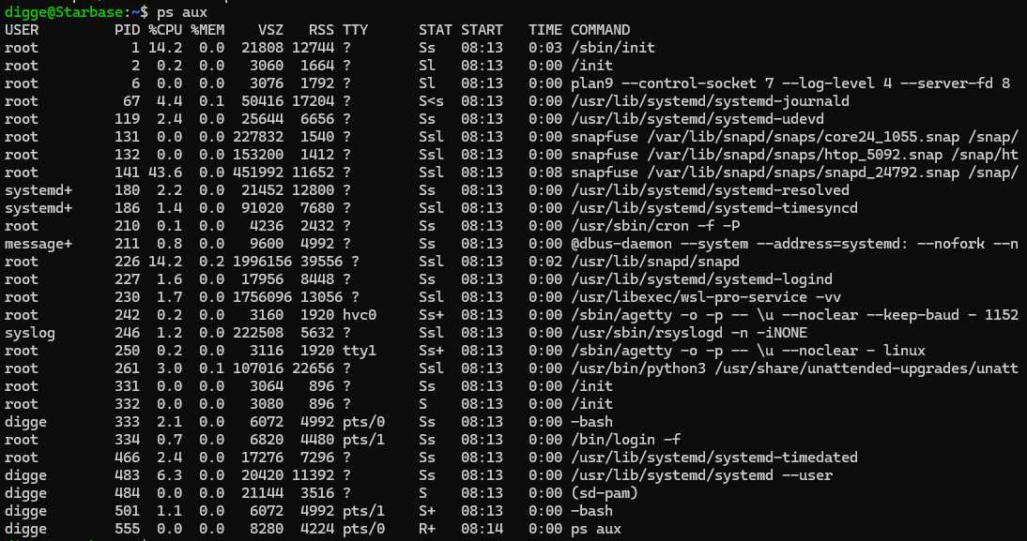
Image 2 (Windows task manager)
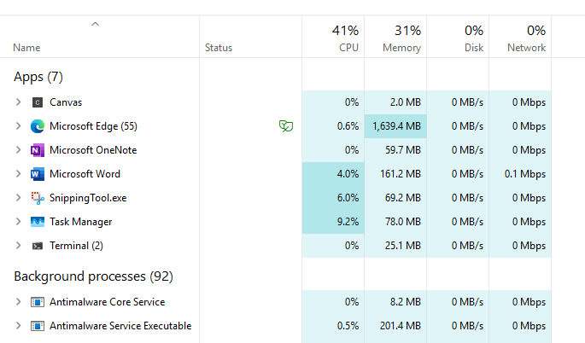
Monitoring Resource Usage
Now that we have a view of the processes that are open, another task to review is how to monitor resource usage. Monitoring resource usage clarifies how different processes/applications affect memory consumption and pressure on the CPU. To see this in Windows you can use task manager and select the processes tab as shown in Image 2 above. The Linux command that provides a similar view is ‘htop’, as shown in Image 3 below. Both tasks are equally easy to perform, however I prefer the Linux output over Windows here because it provides more detail like the actual memory consumption against the total (356M/15.5G) instead of an overall percent format.
Image 3 (Linux ‘htop’)
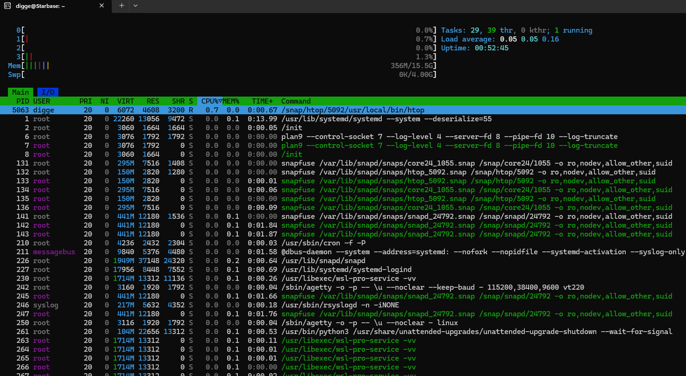

Terminating Processes
Another important task in managing processes within operating systems is terminating processes. This is important for both operating systems when, “you may need to terminate a process due to various reasons such as a process becoming unresponsive, consuming excessive resources, or simply because you no longer need it to run”. (Staff Writer, 2025) This can be managed via the Windows task manager by selecting a task via left click mouse then selecting End Task from the upper menu, as shown in Image 4 below. There are a couple of commands to do the same task in Linux including ‘kill’ from the ‘htop’ screen as shown in Image 5 as well as ‘pkill’ and ‘killall’. I prefer the Windows experience for this task because I feel more confident that I’m solely ending the process I want to end by name which reads more cleanly for me.
Image 4 (Task Manager – End Task)
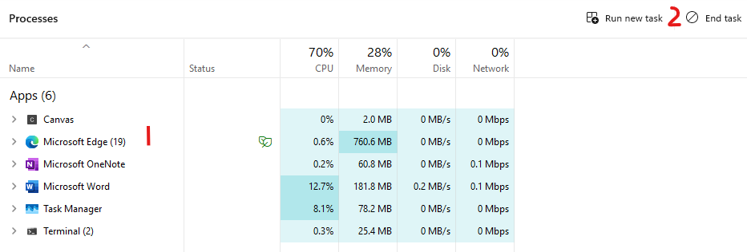
Image 5 (Linux ‘kill’)
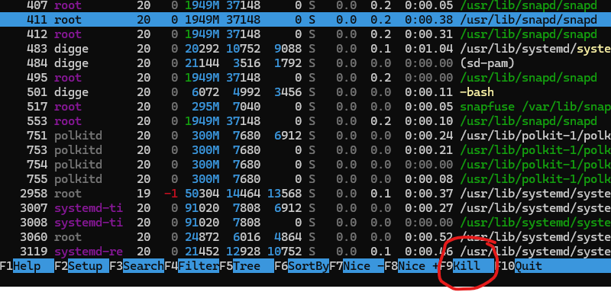
Changing Process Priority
Although this task may not be performed as frequently as others, it’s important to understand why and how to change the process priority within an operating system to optimize performance and to prevent system instability. William Stallings calls out a real-life example of priority issues with the Mars Pathfinder mission when, “… a few days into the mission, the lander software began experiencing total system resets, each resulting in losses of data”. (Stallings, n.d) This issue was traced to Priority Inversion and later solved by using a priority ceiling approach. The following examples shown in Images 6 & 7 aren’t as complex as that solution but show how a task priority can be manipulated in both Windows and Linux environments. Both seem equally usable for me, however it’s nice (excuse the pun) to see the old priority next to the new in Linux ‘renice’, and you have more options for prioritization 0-20 over the 6 options in Task Manager.
Image 6 (Task Manager – Details tab)
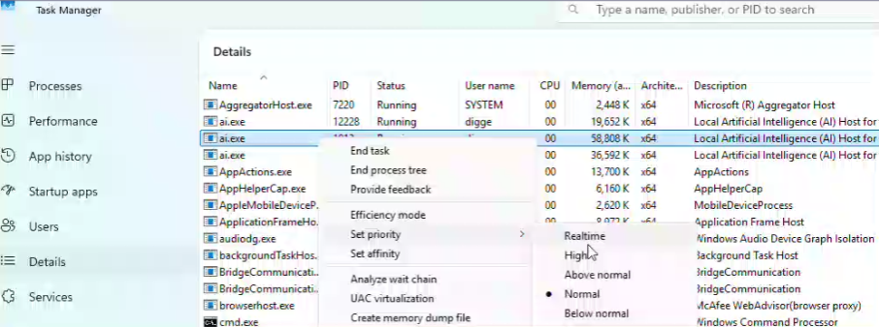
Image 7 (Linux ‘renice’)
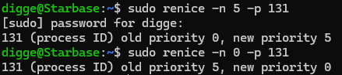
Process Hierarchy and Relationships
The last task I’ll explore is process hierarchy and relationships. Getting a good view of this at a high level can help a user understand their relationships and can help manage resource sharing and communication between the processes. This can be viewed in Windows Task Manager details tab as shown in Image 8, and Image 9 show the ‘pstree’ command run in Linux. I prefer the Linux view because it reveals a true tree relationship whereas Task Manager merely groups them together. I would look outside of Task Manager if I wanted to find a better hierarchy relationship with the Windows OS processes in flight.
Image 8 (Task Manager – details tab)
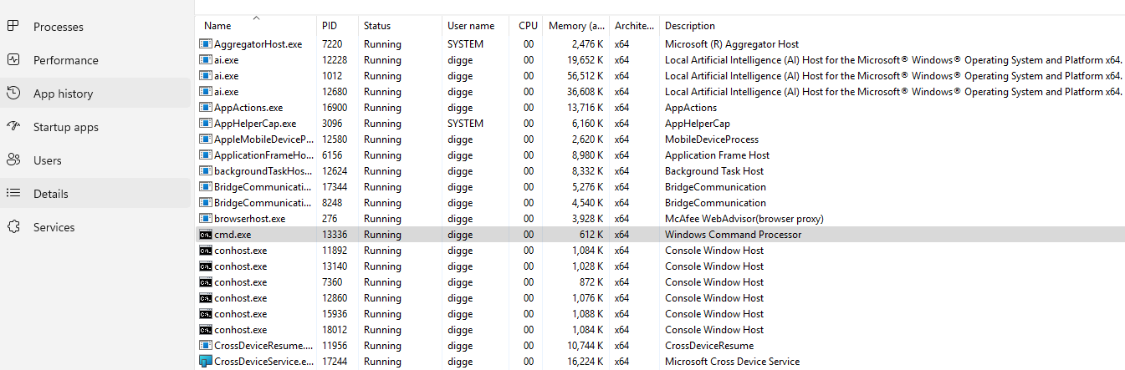
Image 9 (Linux – pstree)
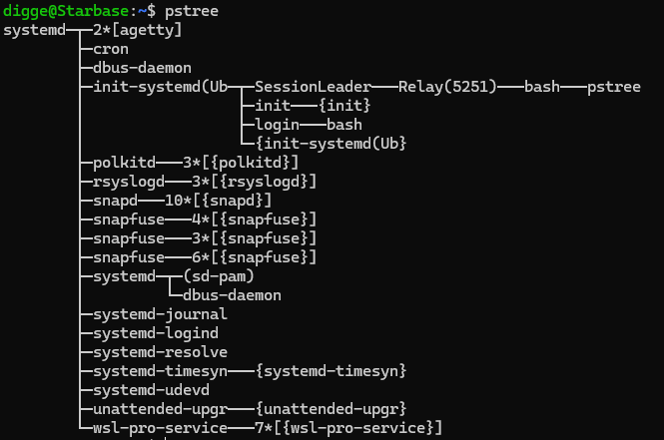
Reflection
This exercise was extremely helpful for me as I continued to learn how to use the Linux environment and some of its more basic capabilities. I prefer the look and feel of Task Manager for some of the tasks I performed like ending a task probably more out of familiarity at this point. Other tasks like changing process priority and viewing hierarchy are better done in Linux in my opinion. I wouldn’t say that I’m a full convert to Linux from Windows yet, but the more I learn and understand both its capabilities and flexibility the closer I am to switching Operating Systems. Walking through basic commands like the five I performed here is a great start and I’m excited to learn more.

References
Staff Writer (2024, March 13). Geeksforgeeks.org. How to List Running Processes in Linux.
https://www.geeksforgeeks.org/linux-unix/ps-command-in-linux-with-examples/
Staff Writer (2025, June 12). Linuxvox.com. Linux Process Termination: A Comprehensive
Guide.
https://linuxvox.com/blog/linux-terminate-process/
Stallings, W. (n.d.). Operating Systems: Internals and Design Principles, 9/e.
Retrieved from https://platform.virdocs.com/read/2228445/105/#/4/2[P7001013869000000000000000003B8D]/12[P7001013869000000000000000003CB0]/40[P700101386900000000000000000D8C0]/2[P700101386900000000000000000D8C1]/2[P700101386900000000000000000D8C2],/5:72,/5:72

